**Module 1_ AWS_Fundamentals_Cloud**

==================================================================================

Submitted to Vikul_Sir

Submitted by Nalathati Rahul

Submission Date –03/Feb/2026

==================================================================================

2. L2 - Login to AWS Console and Create IAM User, Role, and Group

**Task 1: Create a User**

Step 1: Go to AWS URL 🡪 <https://aws.amazon.com/console/> 🡪and login with Credentials

Step 2: Go to AWS Search Bar, Search for IAM (Identity and Access Management) Service. And click on it.

IAM 🡪 is core security service that lets you securely control access to AWS services and resources

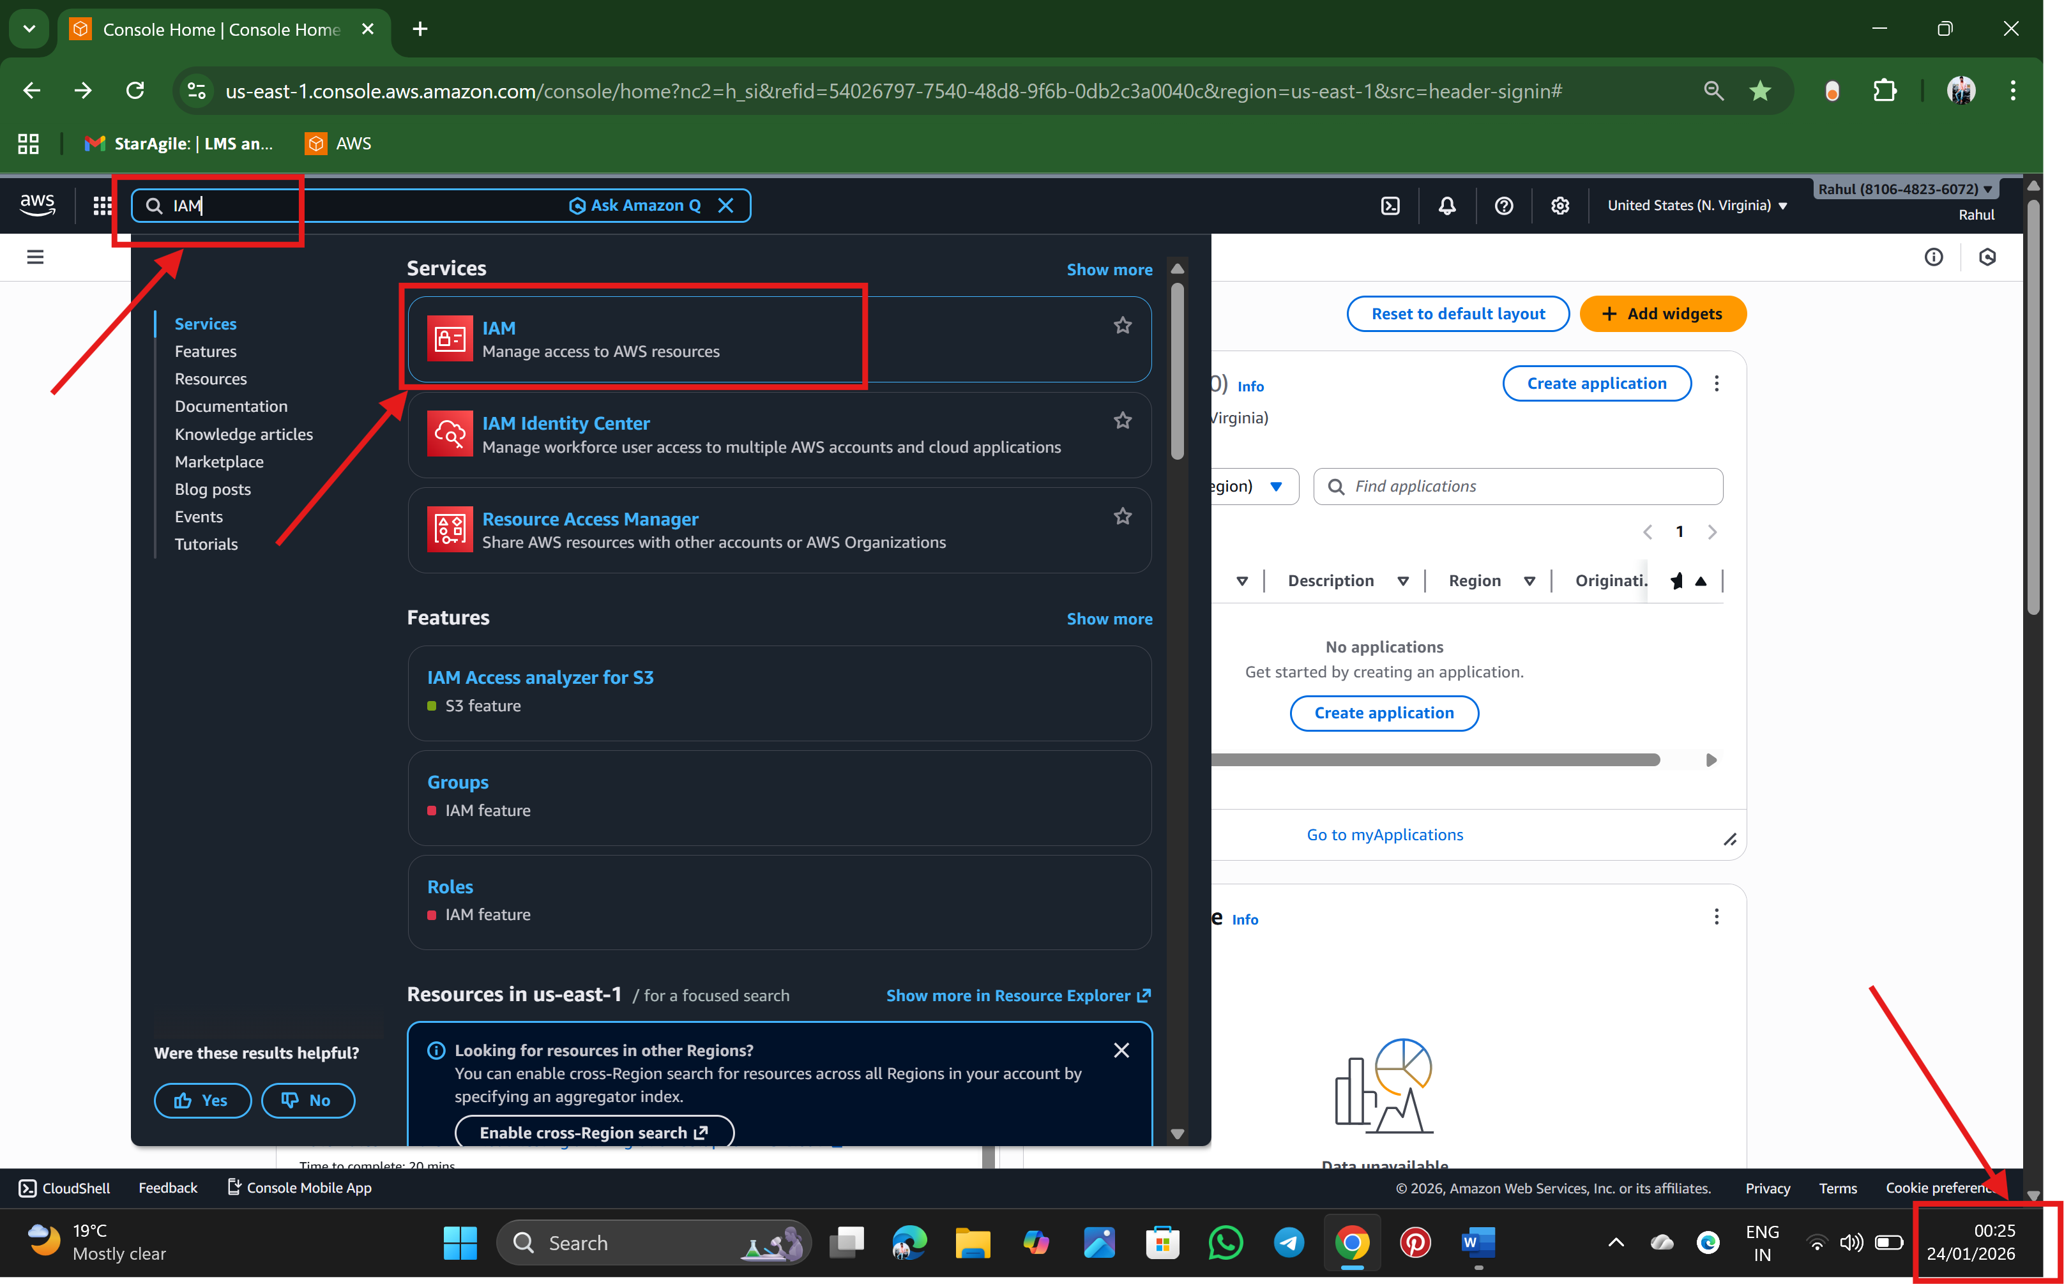

Step 3: After an IAM Dashboard will appears with a Root User

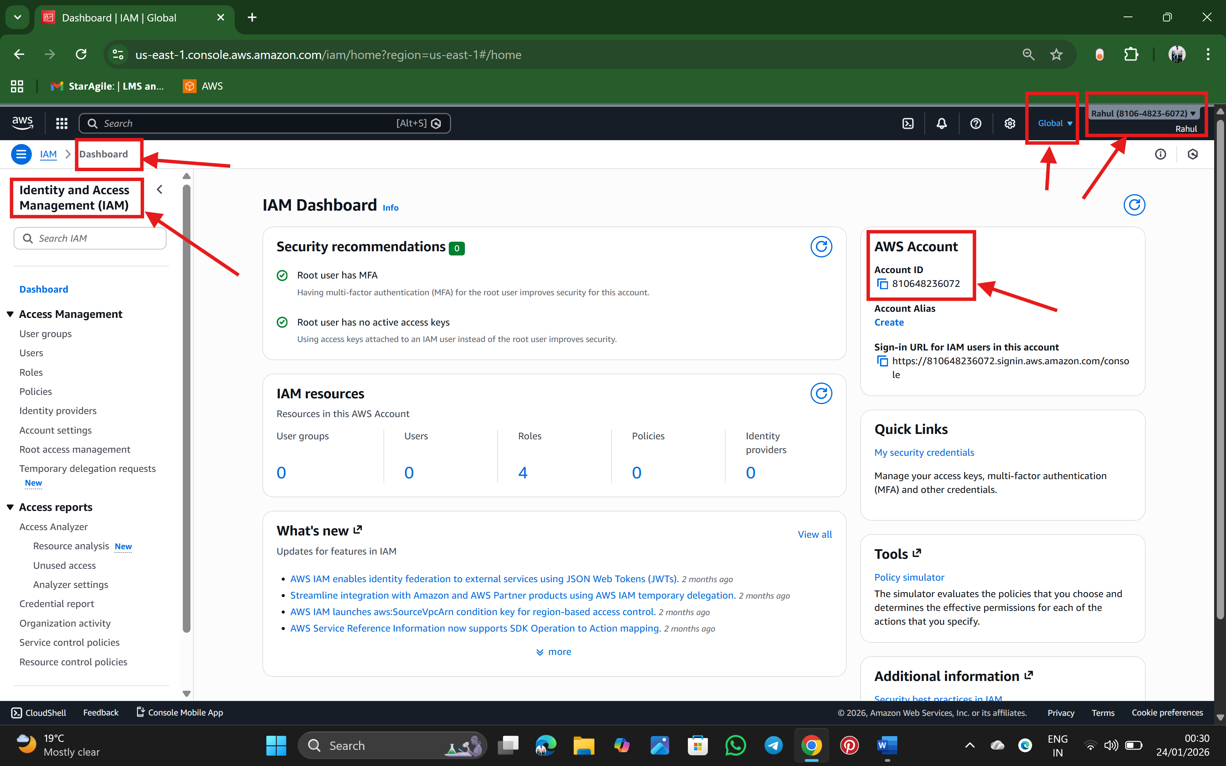

Step 4: Create a IAM User by using a option from left side of IAM Dashboard

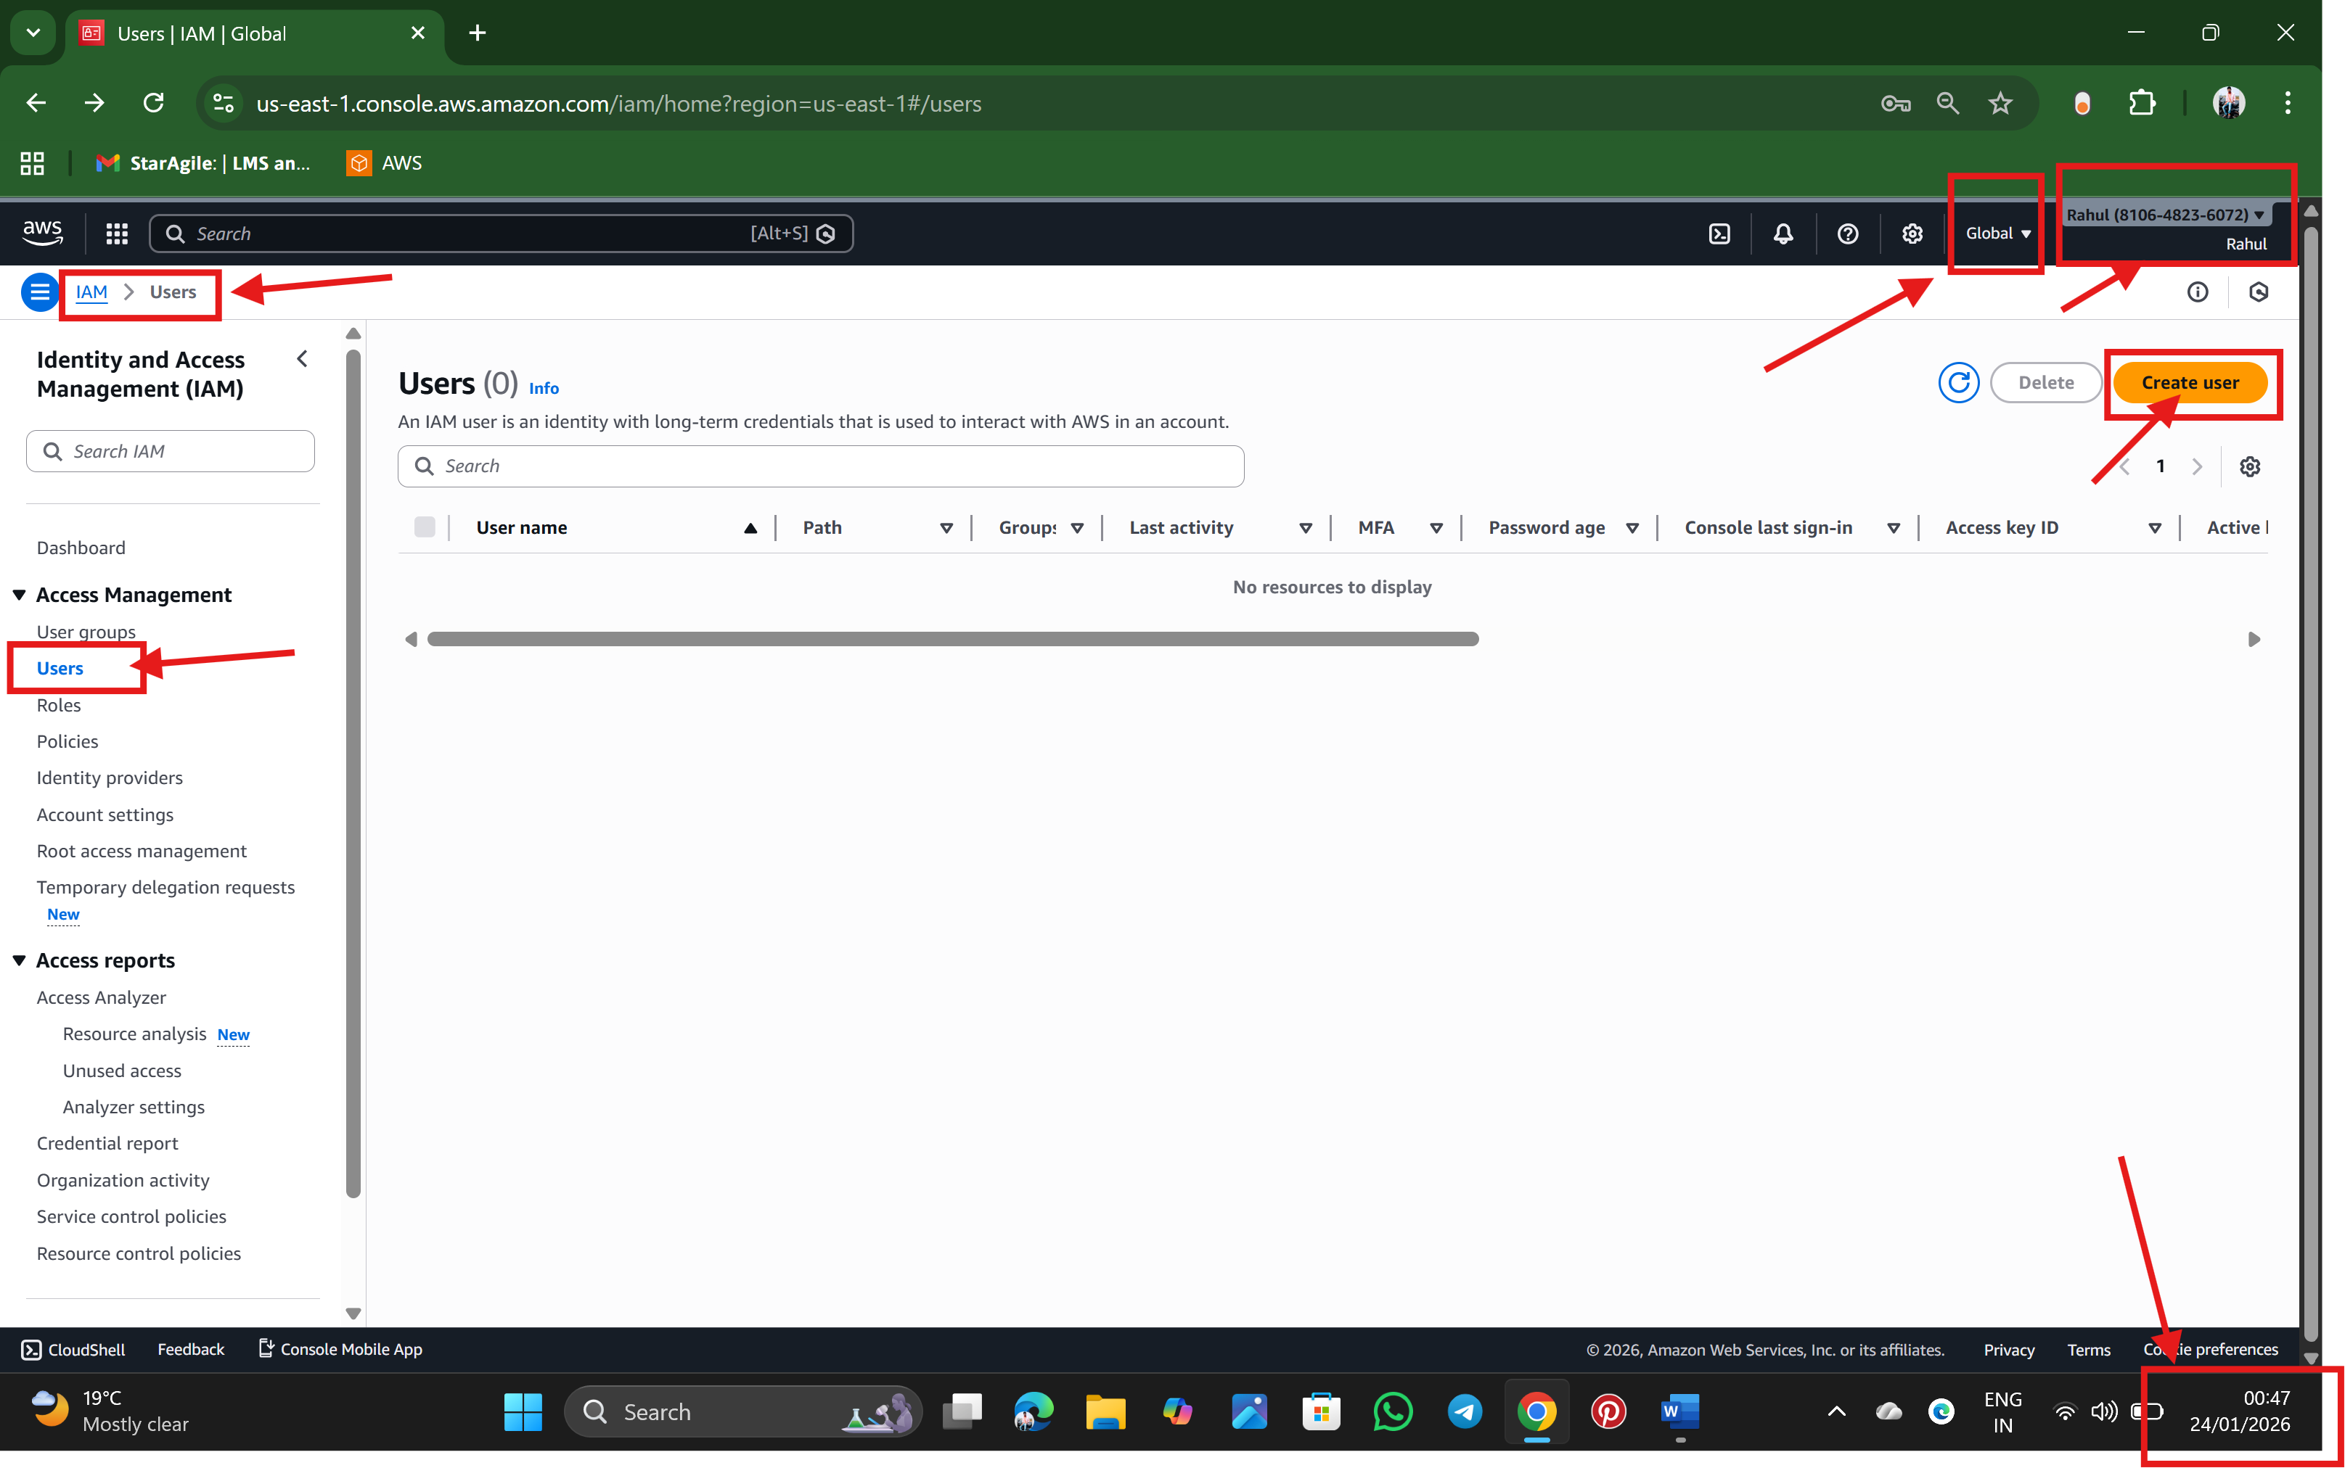

Step 5: Give user Name as Rahul with Custom/ Autogenerated Password for Specify user details. (Stage 1) and Click Next

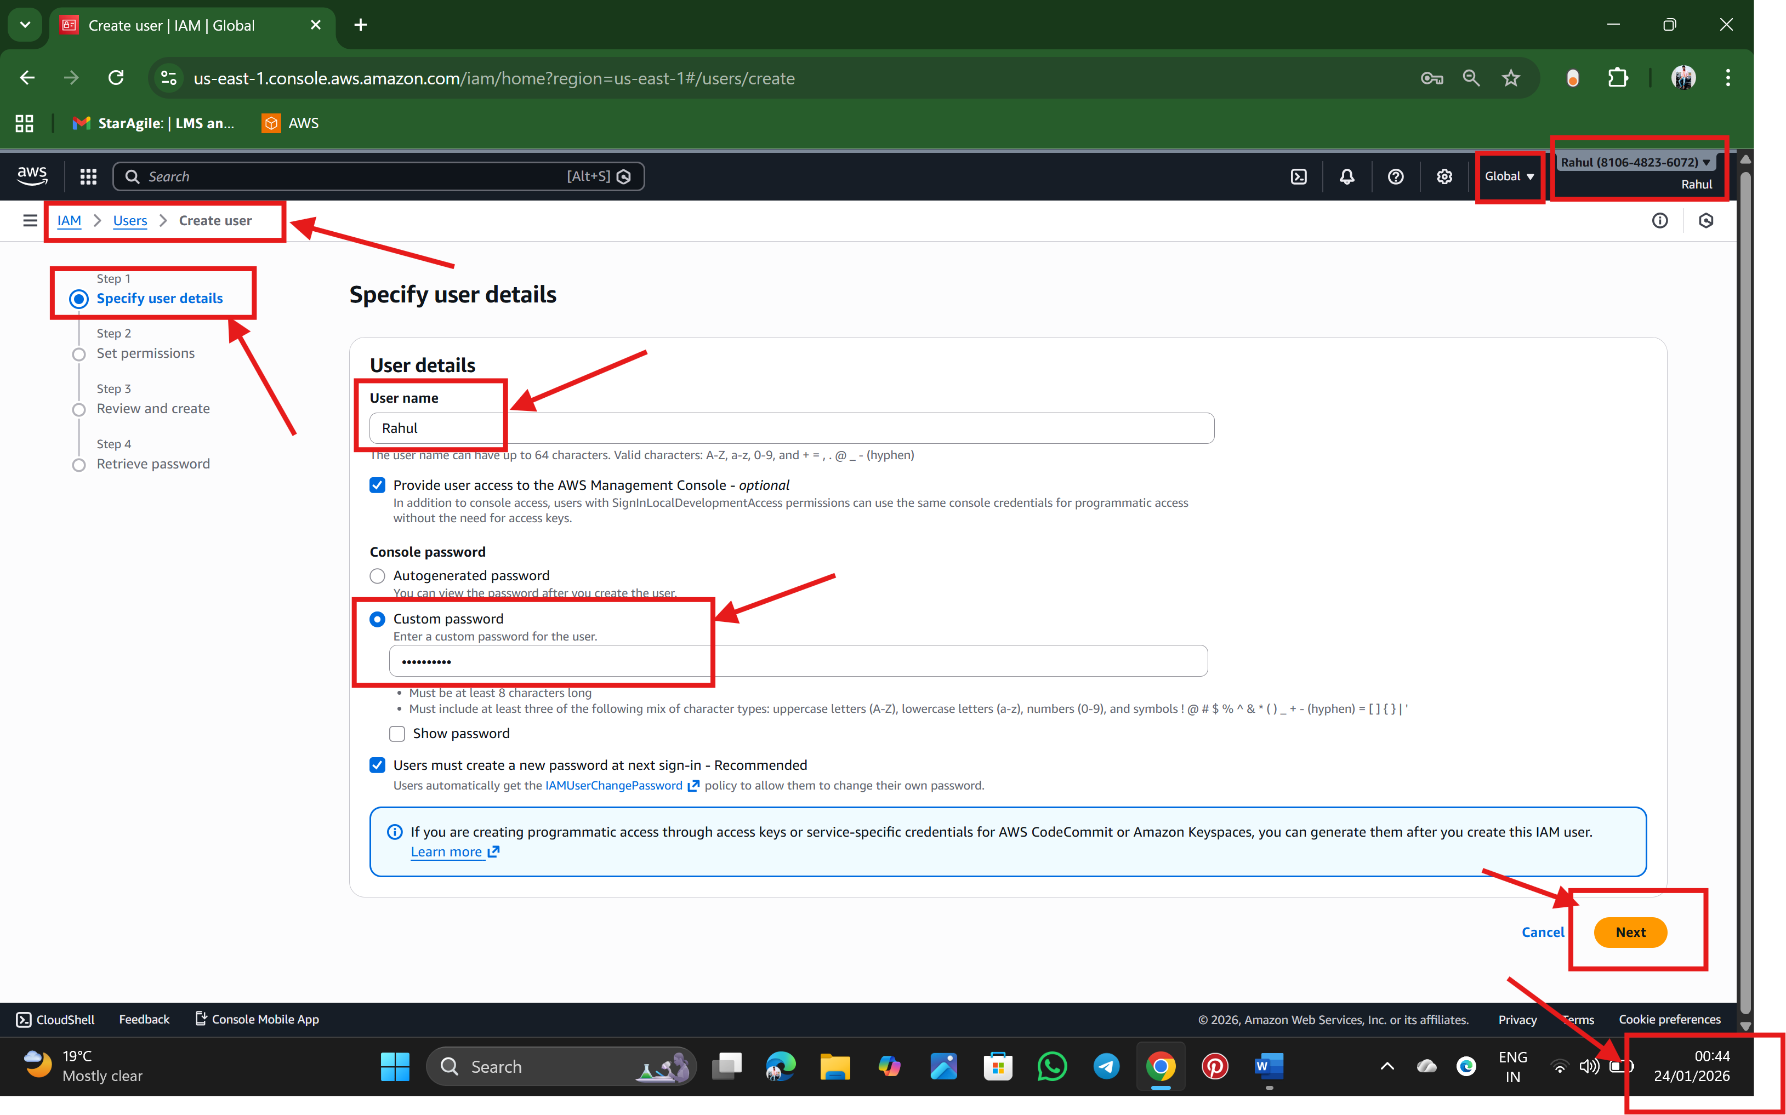

Step 6: As window go next and Ask to Set permissions (stage 2) base of Three option as per our Requirement. And click next

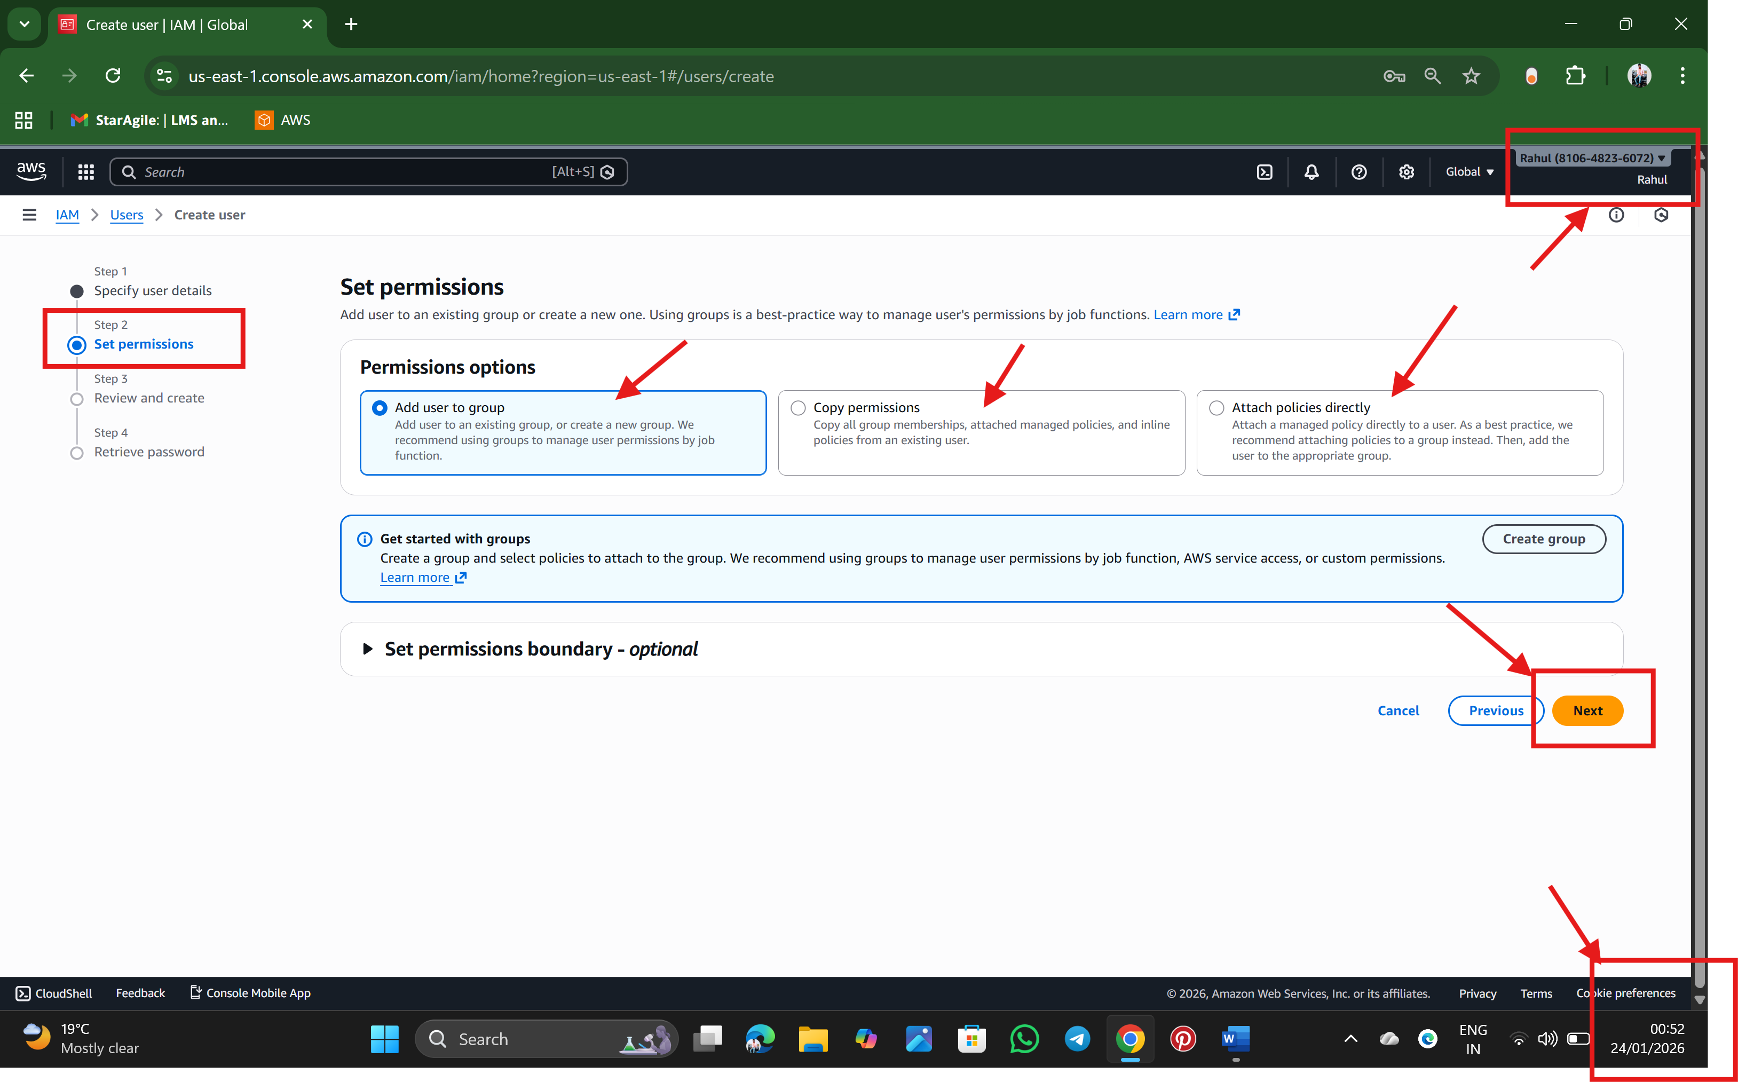

Step 7: As window go next and Ask to Review and create (stage 3) which shows the details of the User and click Create User.

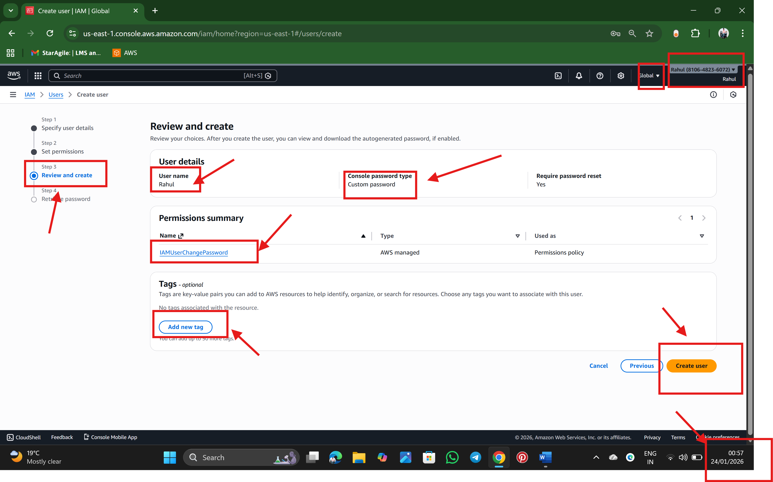

Step 7: Finally, a User with name Rahul is successfully created

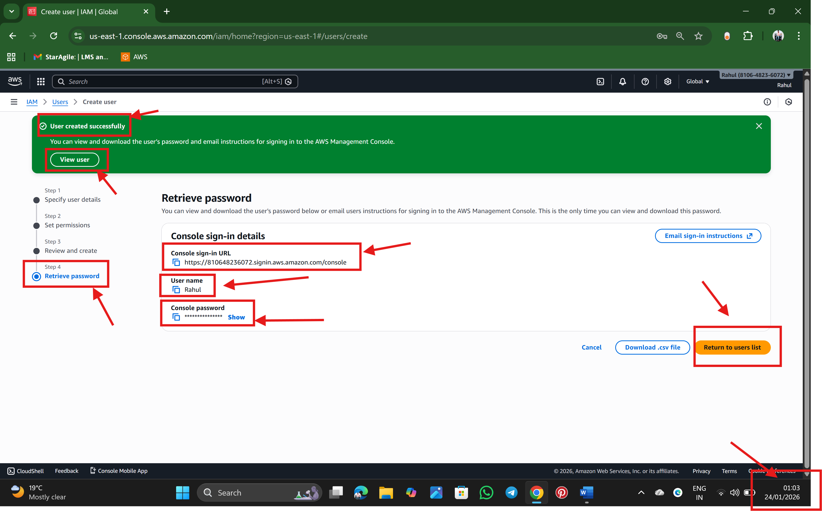

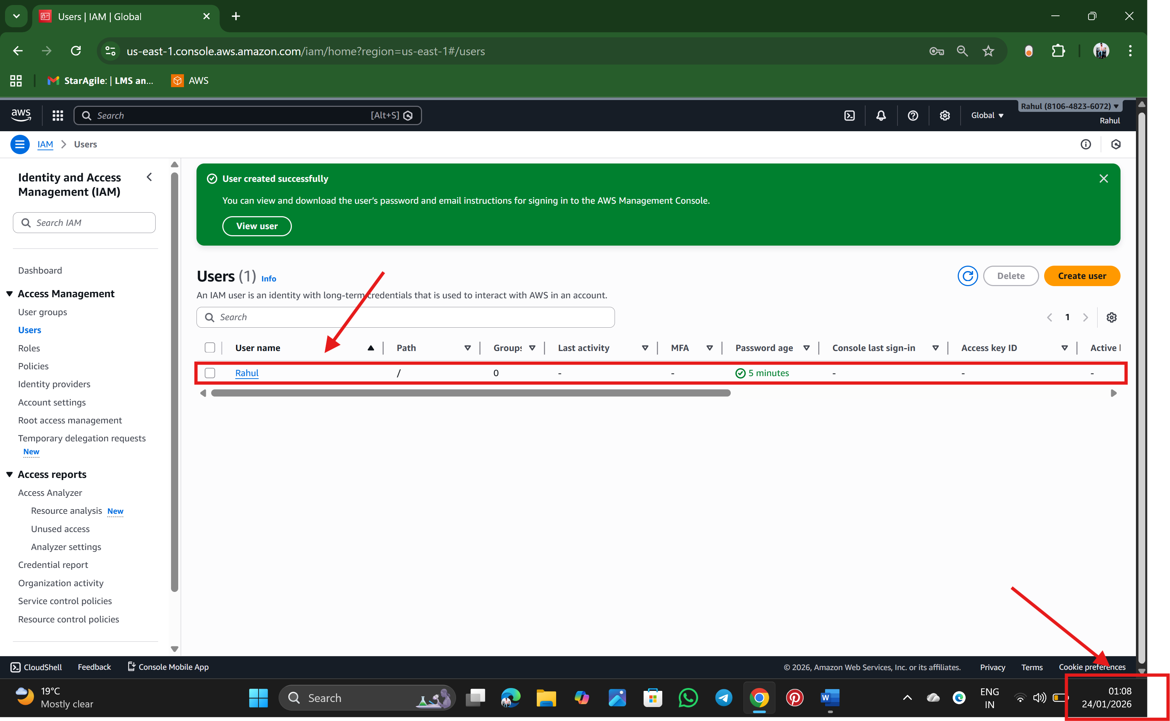

==================================================================================

**Task 2: Create a Role**

Step 1: In an IAM Dashboard on left side we will find a Role option click on it and create a Role

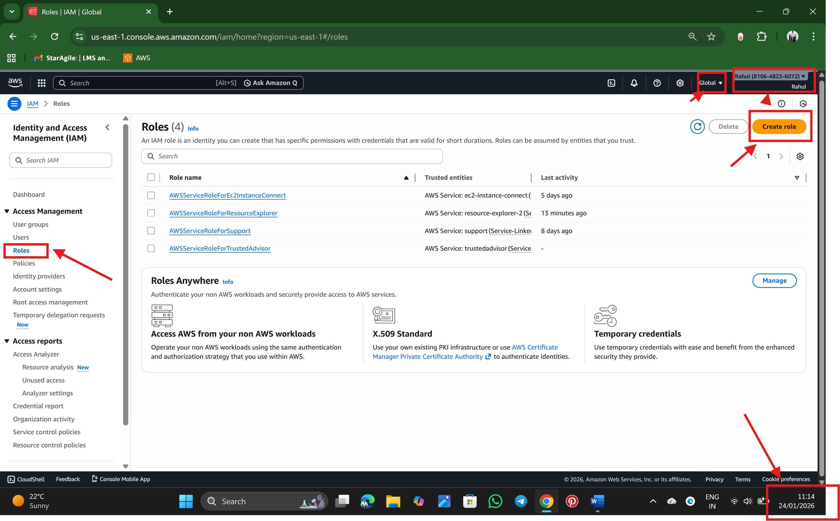

Step 2: As a window goes to next, after clicking a create role, we find select trusted entity as stage1, we seek options like AWS service, AWS account, web identity, SAML 2.0 federation and Custom trust policy. So, example select AWS account and click next

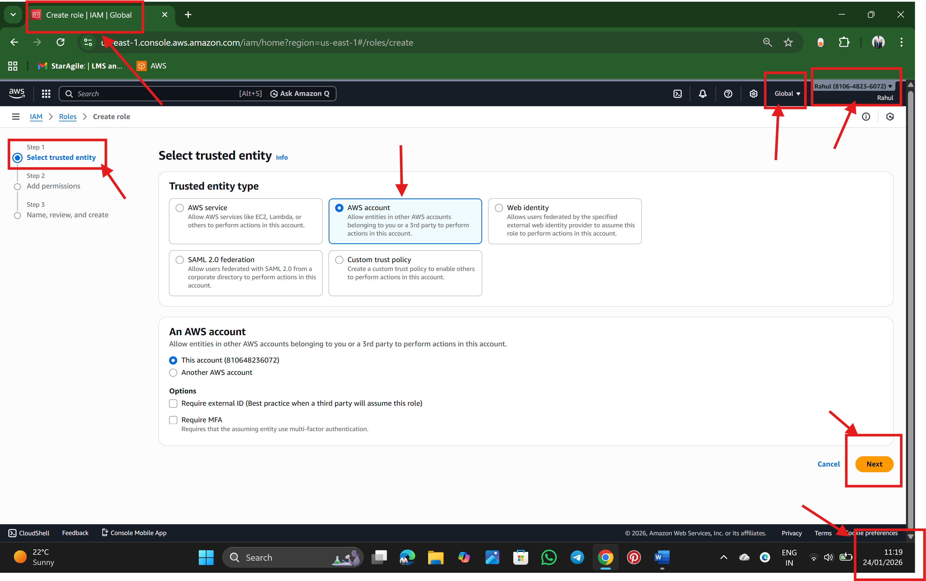

Step 3: As a window goes to next, after clicking next, we find add permission stage 2, and in search bar search the permission we want to assign to a user. Example AdministratorAccess and click on next. Note: Be caution, while giving an Admin level permissions

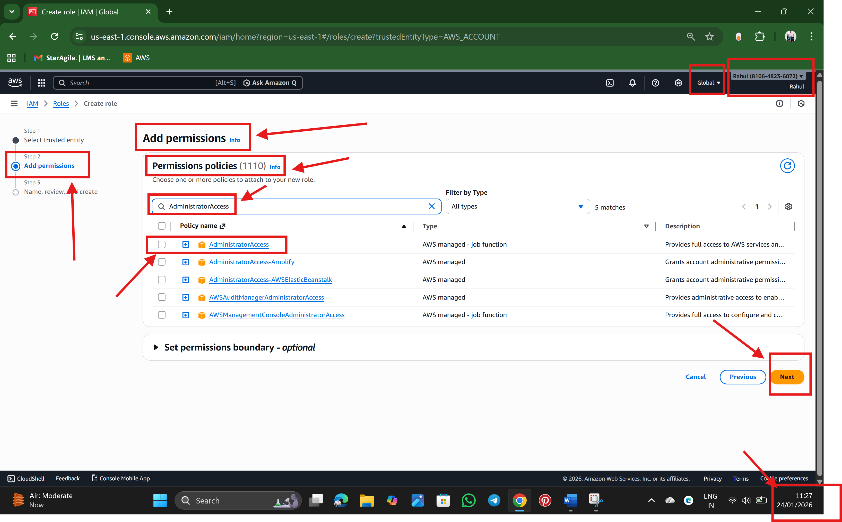

Step 4: Step 3: As a window goes to next, after clicking next, we find Name, review, and create---- stage 3 and enter Role name and check the select trusted entities policy and click create a role 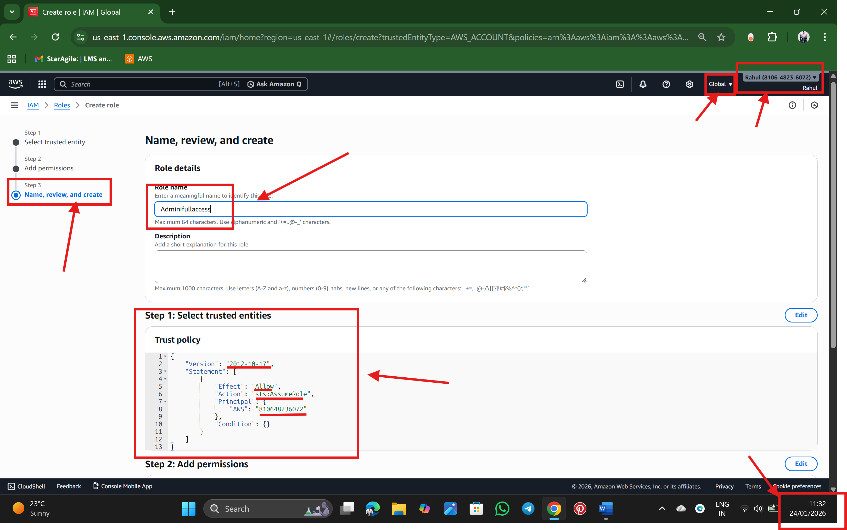

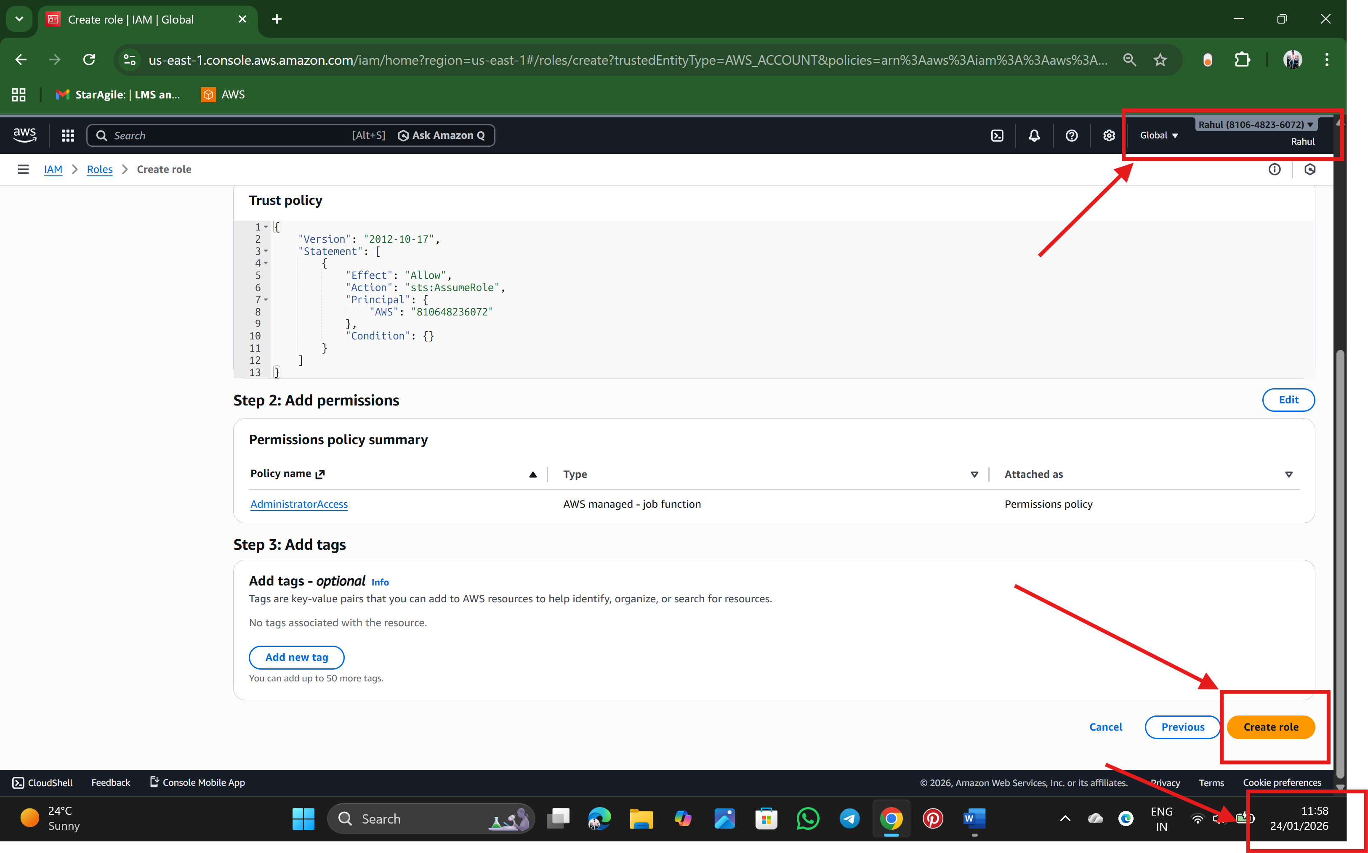

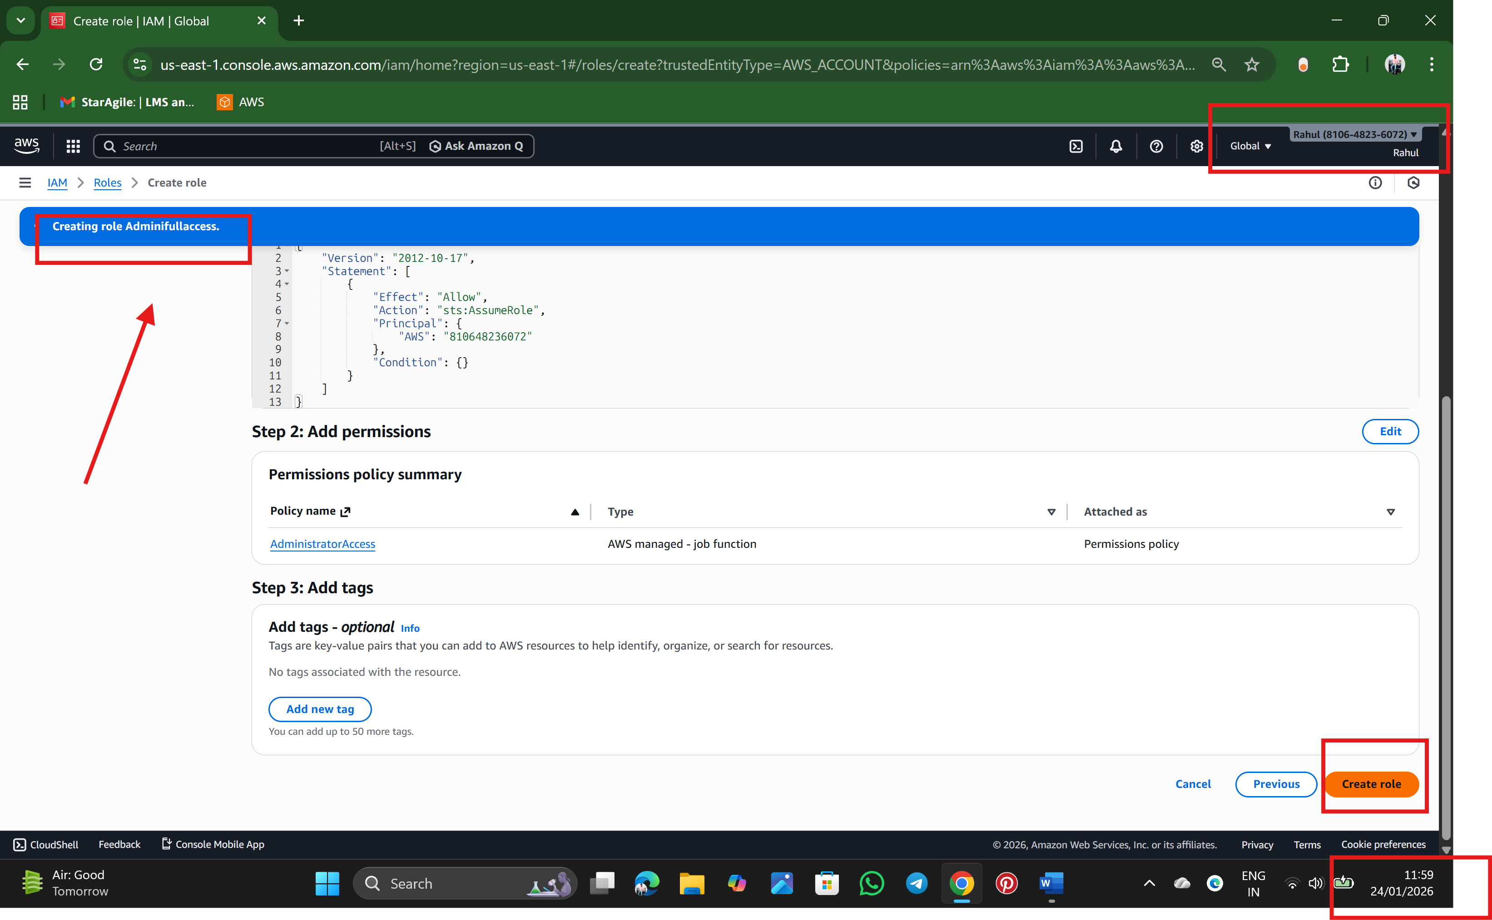

Step 5 : Finally, Role is Created

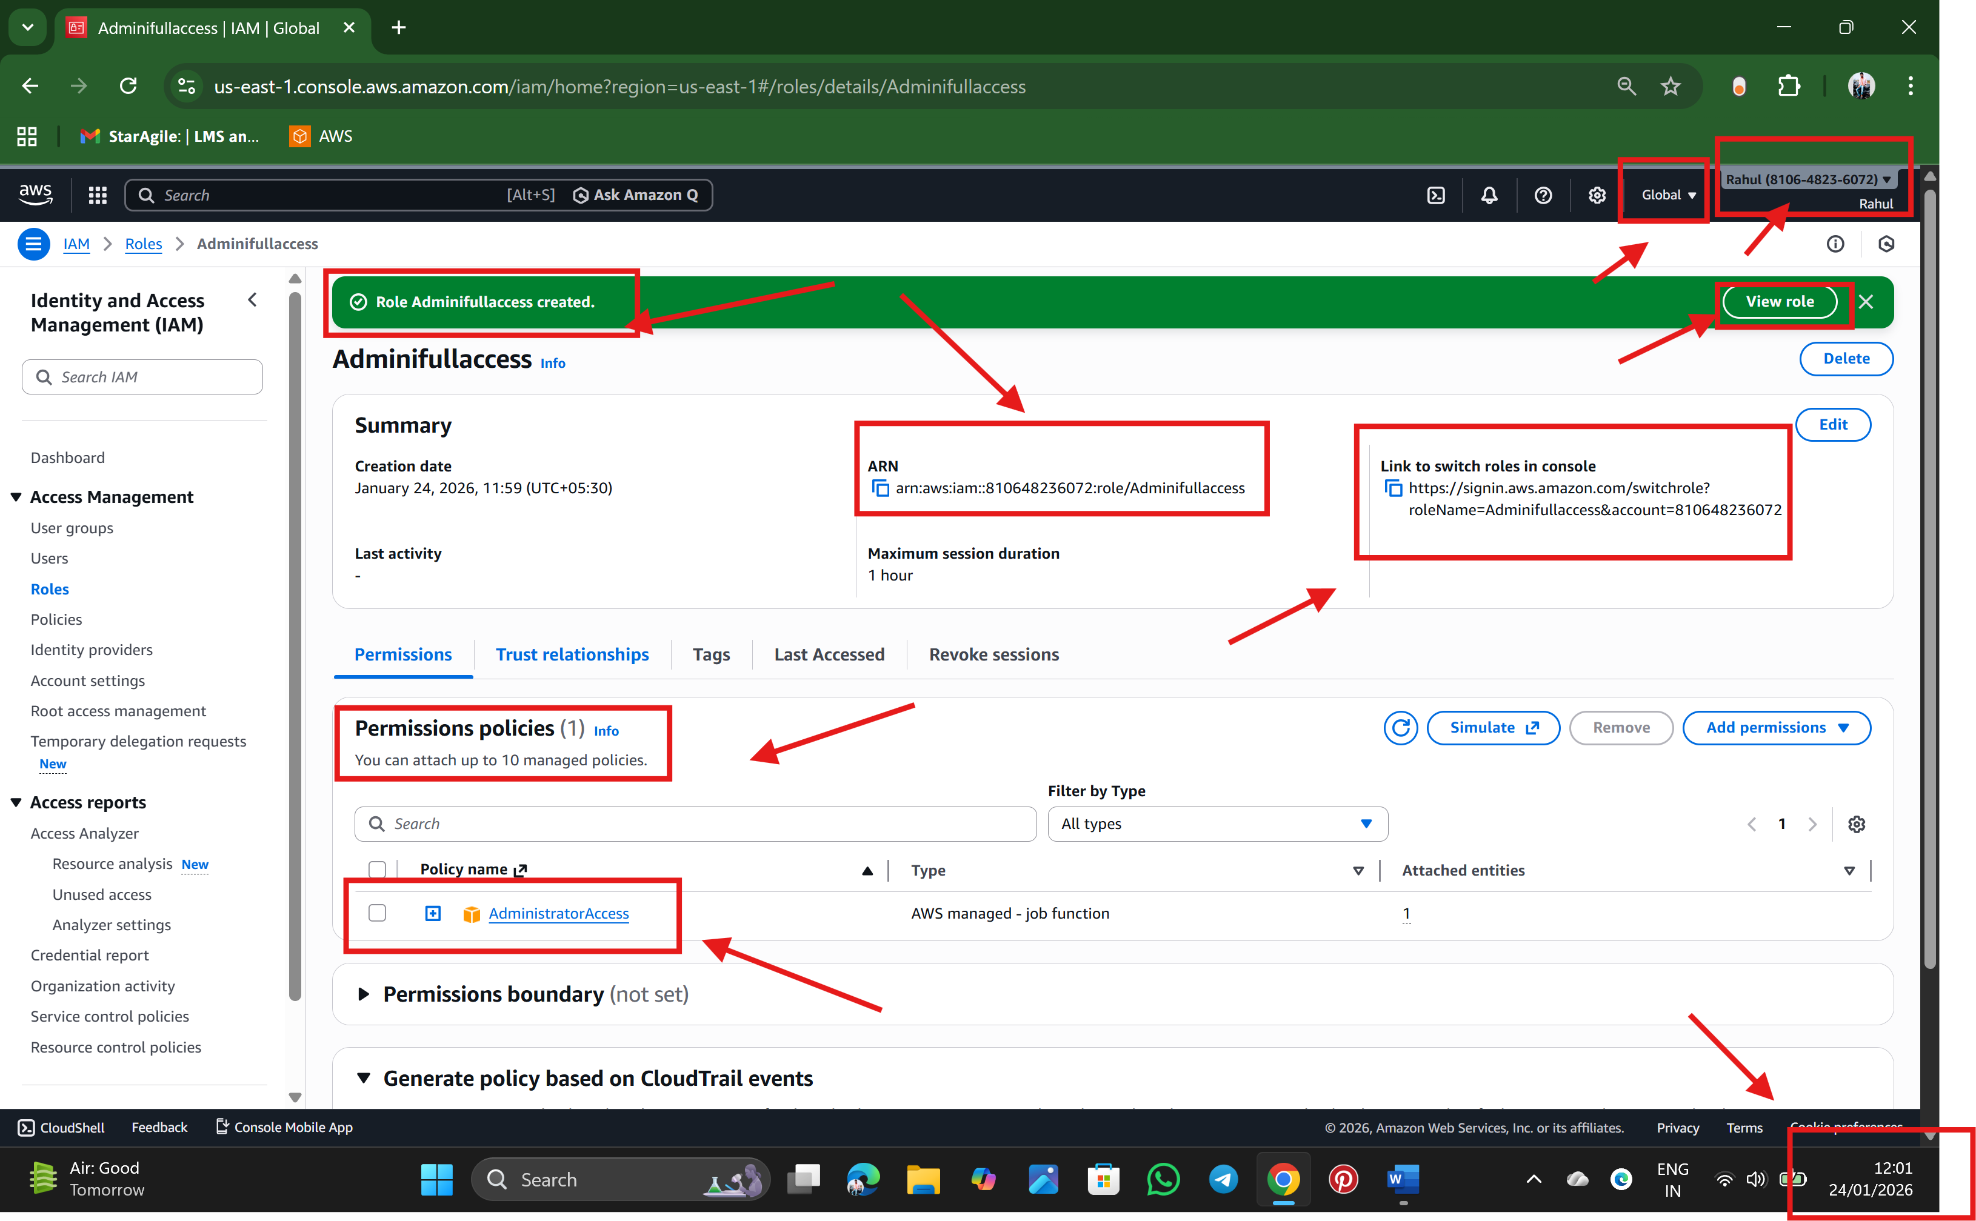

==================================================================================

Task 3: Create a Group

Step 1: In an IAM Dashboard on left side we will find a User Groups option click on it and create a Group

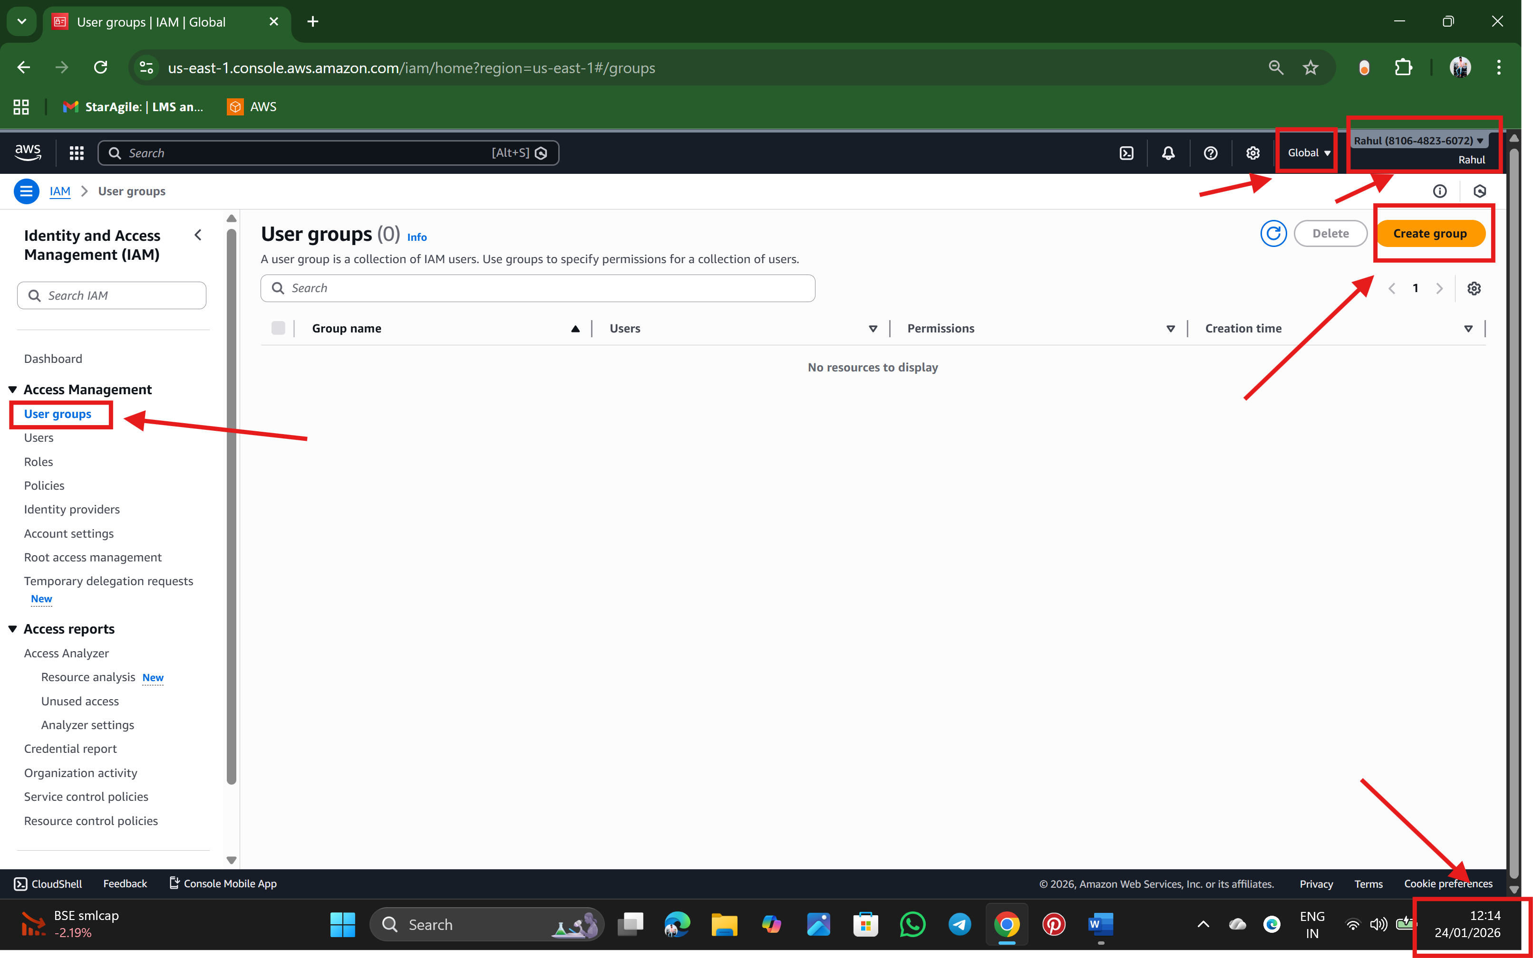

Step 2: As a window goes to next, after clicking next, we find Create a group name, and attach permissions (if we require), which is optional and click a create a user group.

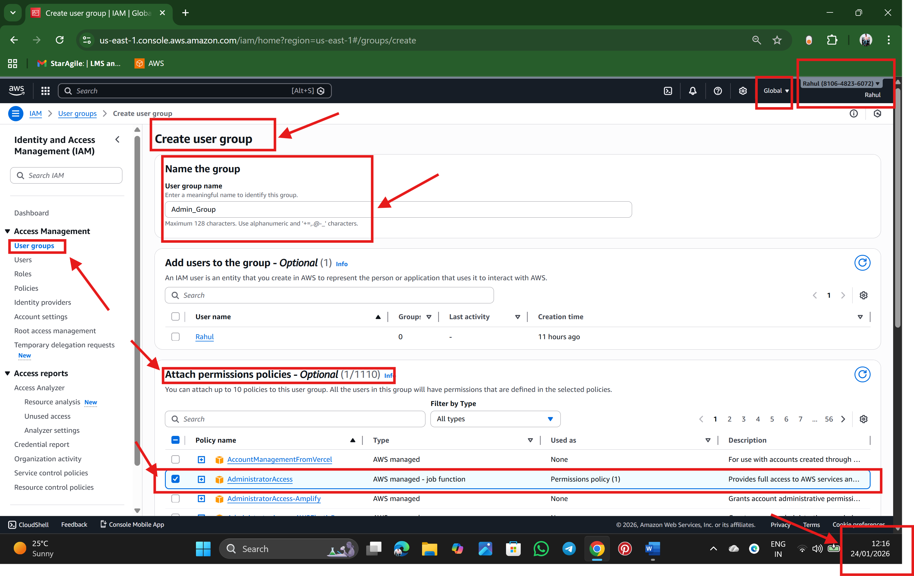

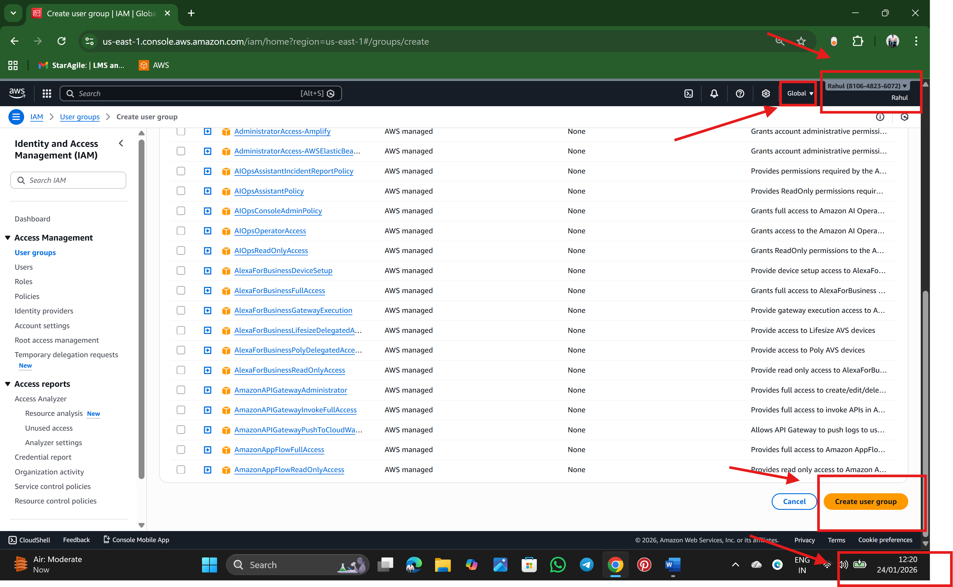

Step 3: finally, a User Group is Created

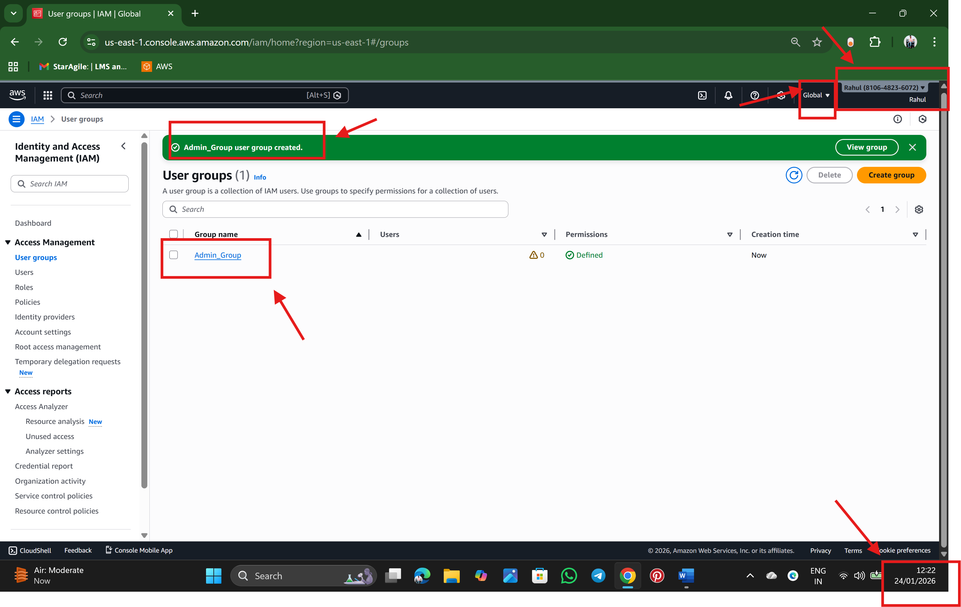

🡪 Rahul Nalathati